

**Schedule Analytics Tool**

**A user guide by GDDT**

**Version 2.0 (October 2019)**



DISCLAIMER

2019 GDDT. All rights reserved.

This training manual is intended for informational purpose only. The information contained in this manual has been obtained directly from Primavera backend databases and the direct calculations and measurements by GDDT. Every care has been taken by the members of GDDT in compilation of the data contained herein and in verification of its accuracy when published, however the content of this training manual is subject to change without notice due to factors outside the control of GDDT and this manual should, therefore, be used as a guide only.

GDDT does not accept any responsibility for misrepresentation by any person of the information contained in this training manual and expressly disclaims all and any liability and responsibility to any person, whether a reader of this training manual or not, in respect of claims, losses or damage or any other matter, either direct or consequential arising out of or in relation to the use and reliance, whether wholly or partially, upon any information contained or products referred to in this manual.

Glossary

The following terms are used throughout the manual to indicate various levels of emphasis when understanding the reports.

 IMPORTANT: Important tips

 HOW TO READ: This explains how to interpret the information

Contents

**Introduction 5**

**Getting Started 5**

**Logging In 5**

**The Interface 6**

**Report Configuration 7**

**Cover Page 8**

**Generating Reports 9**

**Single-Schedule Check 9**

**Multi-Schedule Checks 9**

**Exporting Report 10**

**Single Schedule Reports 11**

**SS-1 Summary Report Merged 11**

**SS-1 Summary Report -1 15**

**SS-1 Summary Report -2 15**

**SS-2 Detailed Valence 15**

**SS-3 Detailed Logic 16**

**SS-4 Detailed Constraint 17**

**Multi Schedule Reports 18**

**MS-3 Activity Compare 18**

**MS-4 Activity / Logic Stats 21**

**MS-5 Venn Diagram 24**

**MS-6 Activity Stats 27**

**MS-7 Float Map 31**

**MS-8 Schedule Consistency 34**

**Automatic Word Export 42**

**Defense Contract Management Agency (DCMA) 42**

**Phase 1 Report 45**

**Contact Us 46**

# Introduction

Welcome to the Schedule Analytics Tool (SAT) user guide. SAT is a fully functional bespoke application which contains a suite of analytics reports to identify schedule inconsistencies, duration changes, logic changes, lag alterations, float distribution, milestone tracking and much more. It eliminates the need to access Primavera Planning Software by directly interrogating its backend server. This promises an utmost 100% accuracy on the information it retrieves.

SAT is designed specifically for consultants and planners to analyse project schedules at the most efficient speed. Reports are automatically generated within a click of a button. This user guide provides detailed information on how to operate SAT as well as how to read and understand the reports.

# Getting Started

Before we get started, it is important to ensure that all required software has been installed and configured correctly. Please contact [GDDT@DRIVERTRETT.COM](mailto:GDDT@DRIVERTRETT.COM) to schedule an installation appointment.

## Logging In

Once SAT has been installed and configured, the application can be accessed by clicking on the icon on our desktop.

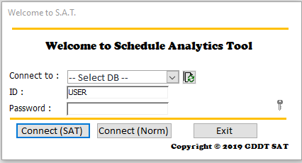When SAT opens, the login screen will be presented. Select the database from the list of dropdowns we wish to connect to, and enter “USER” as the ID, “password” as the password, before clicking on ***Connect (SAT)***.

## The Interface

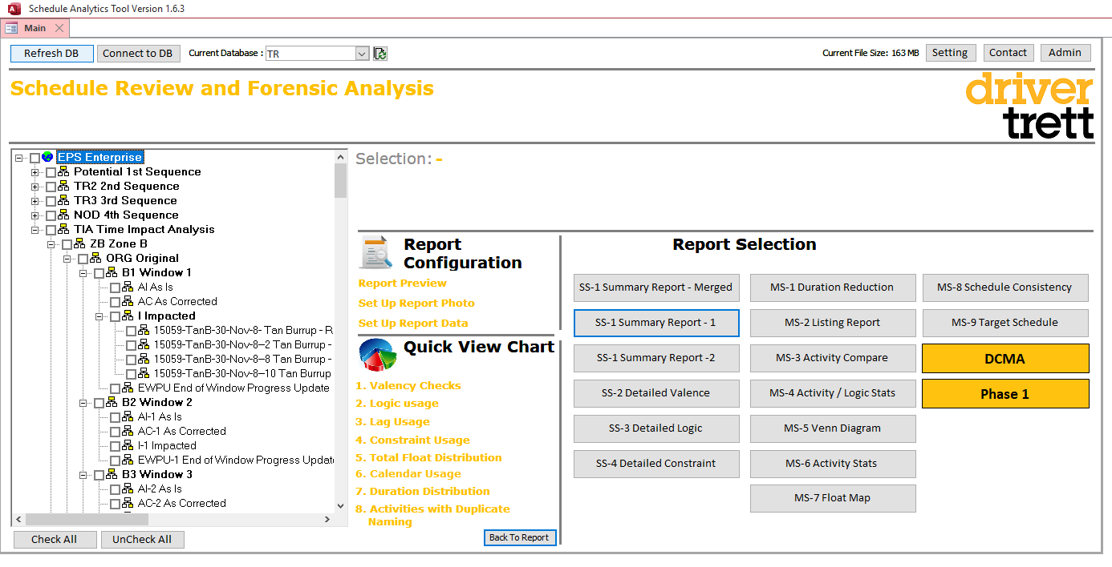After logging in, we will be taken to the main interface.

**1**

**2**

**7**

**6**

**5**

**4**

**3**

For users with multiple databases in their machine, we can quickly alternate between them using this list of dropdowns. Click “Connect to DB” after selecting and the dataset will be refreshed.

**1**

GDDT contact details are stored within the Contact button in the event we wish to contact any of our members for assistance.

**2**

A mirrored EPS structure of our database is shown here. It is exactly as how we would see in Primavera. Click on ‘Check All’ and ‘UnCheck All’ to select all or un-select all schedules.

**3**

This displays the information of the project schedule. (More details are given in the next section)

**4**

This section allows us to configure our report by creating a tailored cover page for each of our clients. (More details are given in the next section)

**5**

This gives us a quick review of the analytical charts without generating a report.

**6**

This is an overview of the suite of reports. (More details are given in the next section)

**7**

# Report Configuration

This section allows us to customise a tailored cover page for each of our clients. The cover page will consist of a project picture (e.g. picture of the construction plant), a project name and a client name. This cover page is attached as the first page of each and every reports.

To customise the project picture, click on “*Set Up Report Photo*”.

Click on “Open” 🡪 “Bitmap Image” 🡪 “Ok”.

Go to “Home” tab 🡪 go to “Paste” icon 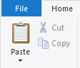 🡪 Click “Paste from” 🡪 Select the picture and click “Open”.

Once selected, close the pop-up by clicking on “x” on the top right. Our project picture is now saved, and we should be able to view it in the square box.

Next, to customise the project name and client name, click on “Set Up Report Data”.

Type in the project name and client name in the bottom 2 boxes.

We have now successfully customised our cover page.

To return to the main menu, click on “Report Preview”.

**IMPORTANT: If a Write Conflict pop-up appears, do not worry. Click on “Copy to Clipboard” and we’re all set.**

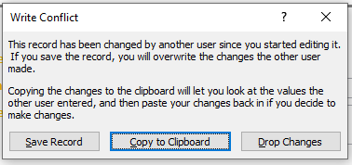

## Cover Page



**Type of Report**

**Client Name**

**Project Name**

** Number of Activities: The processing time needed to generate a report depends on the number of activities. Larger report takes longer time.**

**Total Number of Activities**

**Schedule Name**

**Schedule Data Date**

**Schedule ID**

# Generating Reports

Our suite of reports consists only of two types – Single-schedule and multi-schedule checks. Single-schedule check analyses only 1 schedule, while multi-schedule check analyses more than 1 schedules. Single-schedule check reports have a prefix of “**SS-**“ while multi-schedule check reports have a prefix of “**MS-**“.

## Single-Schedule Check

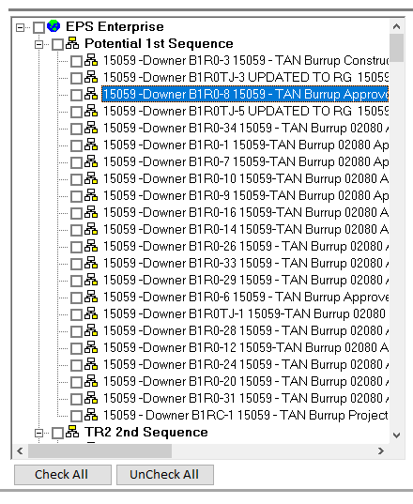To generate a single-schedule check, click on any of the schedule in the EPS tree-view on the right. When a blue band appears, our single schedule has been selected.

**Blue band**

**A Concatenation of Schedule ID & Schedule Name**

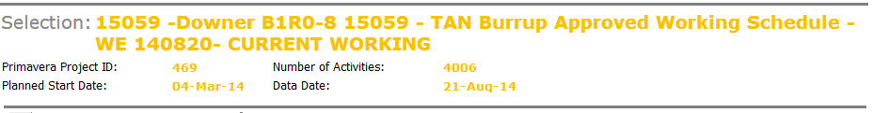When a schedule has been selected, its information is displayed in the selection section.

**System ID**

**Number of Activities**

**Planned Start Date**

**Data Date**

## Multi-Schedule Checks

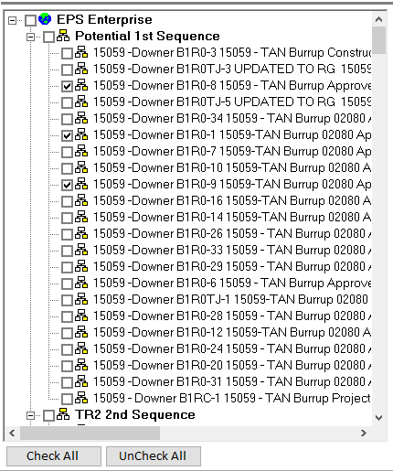To generate a multi-schedule check, click on more than 1 of the checkboxes. There is an easy “check all” and “uncheck all” to clean up checkboxes if we need to restart the selection process.

# Exporting Report

After a report is generated, it is recommended to first export it out onto our machine.

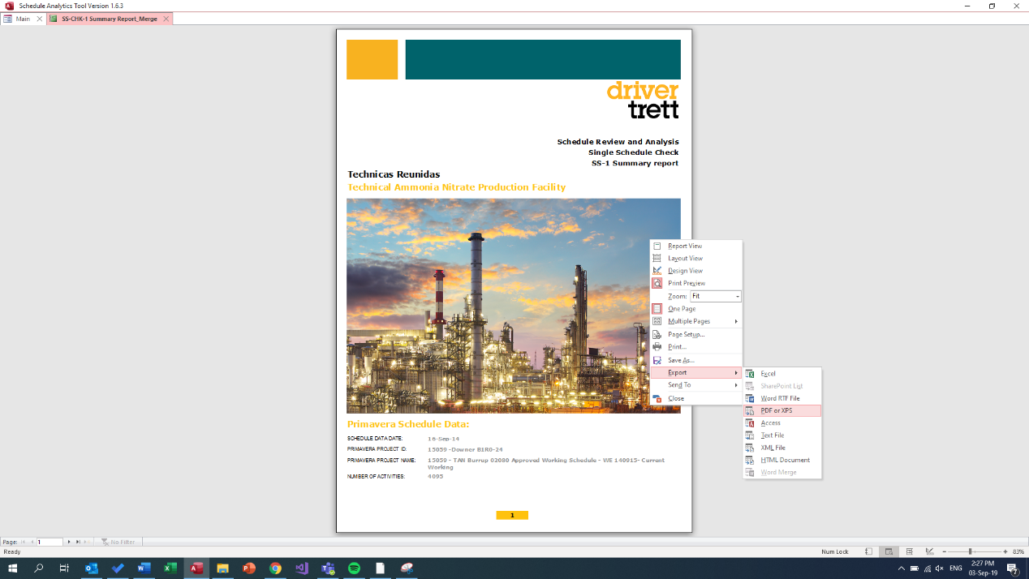To do this, right click on the report, click “**Export**”, and then “**PDF or XPS**”. Specify the directory location which we like to save it in and give it a name. When we are done, click “Publish”.

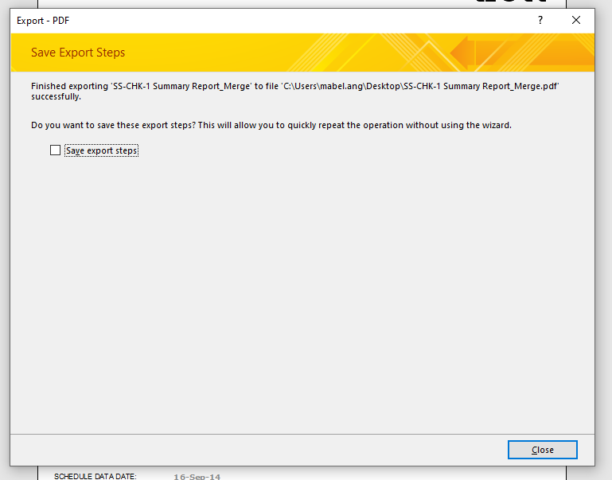Upon success, a pop-up message will appear stating the completion of an export onto our specified location. Finally, click on “**Close**”. The report is now saved onto our machine.

To return to the main menu, we can either right click on the report and click “**Close**”. Or, go on the tabs at the top left and hit the “**X**” button.

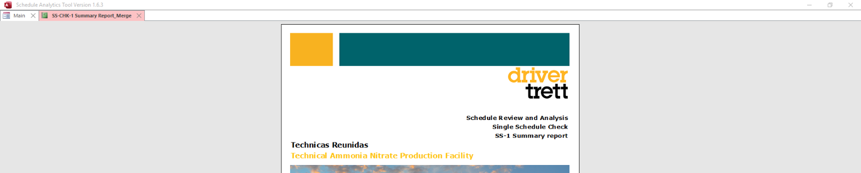

# Single Schedule Reports

## SS-1 Summary Report Merged

SS-1 Report gives us an overall glance of the schedule quality. It analyses valence conditions, logic usage, lag distribution, constraint usage, float distribution, as well as actual dates after data date.

**Valence Conditions**

Valence Conditions graph gives the number of activities for each valence conditions.

|  |  |
| --- | --- |
|  | Image result for READ ICON HOW TO READ: There are 32 activities with *No Predecessor*, 137 activities with a *No Successor*, 325 activities with a *No Predecessor Driver Start*… |

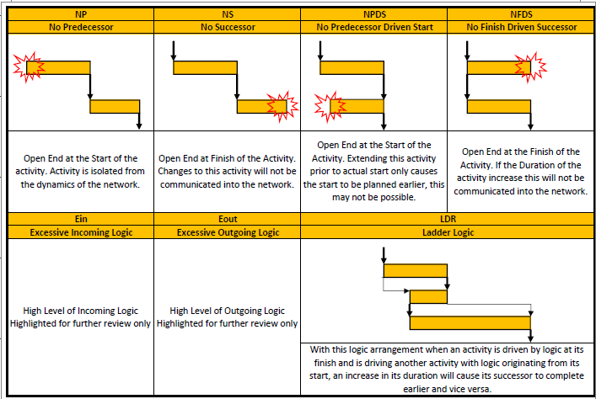The table below explains in detail when each valence conditions occur.

 IMPORTANT:

**EIN** = If there are more than 10 predecessors attached to an activity

**EOUT** = If there are more than 10 successors attached to an activity

**Logic Usage**

Logic Usage graph gives the number of logic links for each logic types.

|  |  |
| --- | --- |
|  | Image result for READ ICON HOW TO READ: There are 3438 logic links with a FF logic type, 7606 logic links with a FS logic type, … |

The table below explains in detail what each logic link represents.

|  |  |
| --- | --- |
| FF | FS |
| Finish-to-Finish | Finish-to-Start |
| Types of Relationships | types of relationships |
| SF | **SS** |
| Start-to-Finish | Start-to-Start |
| Types of Relationships | Types of Relationships |

**Lag Distribution**

Lag Distribution graph gives the number of links for each lag distribution range.

|  |  |
| --- | --- |
|  | Image result for READ ICON HOW TO READ: There are 22 logic links with lag ranging from [-25,-1], 10253 logic links with a lag of 0, 1393 logic links with lag ranging from [11,25], … |

**Constraint Usage**

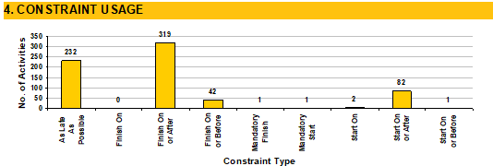Constraint Usage graph gives the number of logic links for each constraint types.

 HOW TO READ: There are 232 activities with a “As Late As Possible” constraint, 319 activities with a “Finish On or After” constraint, 42 activities with a “Finish On or Before” constraint …

The table below explains in detail the different constraint type:

|  |  |
| --- | --- |
| Constraint | Explanation |
| As Late As Possible | To schedule the activity to start as late as it can without delaying its successors |
| Finish On | To specify the exact date for which the activity to be completed |
| Finish On or After | To establish the earliest possible date that an activity could end |
| Finish On or Before | To establish the latest possible date that an activity could end |
| Mandatory Finish | To specify the exact date for which the activity must be completed |
| Mandatory Start | To specify the exact date for which an activity must start |
| Start On | To specify the exact date for which an activity start |
| Start On or After | To establish the earliest possible date that an activity could start |
| Start On or Before | To establish the latest possible date that an activity could start |

**Lag Distribution**

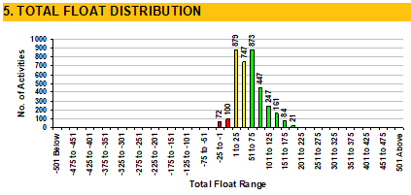The total float distribution graph gives the number of activities in each float range.

 HOW TO READ: There are 72 activities with a float ranging from [-25,-1] days, 100 activities with a float of 0, 879 activities with a float ranging from [1,25] days …

The table below gives the breakdown of the colours appearing in the float graph.

|  |  |
| --- | --- |
| **Total Float Range** | |
|  | Red bar = float range less than or equal to zero |
|  | Orange bar = float ranging from 1 to 25 days |
|  | Yellow bar = float ranging from 26 to 50 days |
|  | Green bar = float range with more than 50 days |
|  | Blue bar = activities that are completed |

**Calendar Distribution**

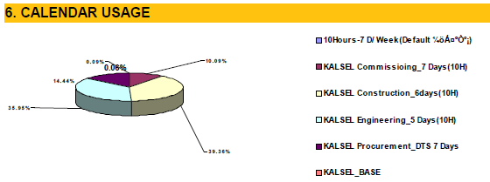Calendar usage pie chart gives the number of different types of calendar that the schedule has used.

**Duration Distribution**

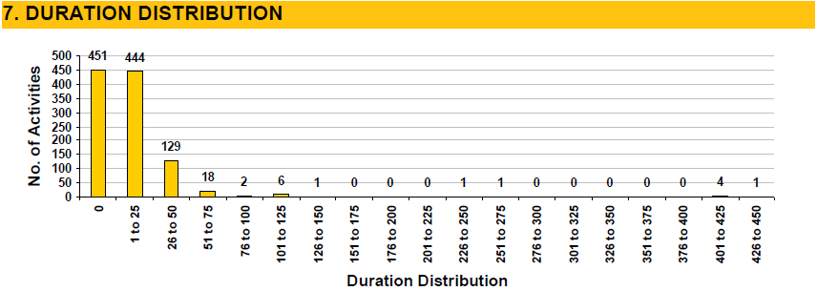The duration distribution graph gives the number of activities in each duration range.

 HOW TO READ: There are 451 activities with a duration of 0 days, 444 activities with a duration range of [1,25] days, 129 activities with a duration range of [26,50] days …

**Actuals After Data Date**

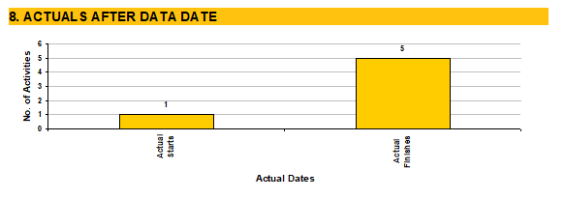The actuals after data date graph gives the number of activities with Actual Starts and Actual Finishes.

 HOW TO READ: There is 1 activity with Actualised Starts and 5 activities with Actualised Finishes after the data date.

## SS-1 Summary Report -1

This is the 1st part of the previous “SS-1 Summary Report – Merged”.

## SS-1 Summary Report -2

This is the 2nd part of the previous “SS-1 Summary Report – Merged”.

## SS-2 Detailed Valence

SS-2 gives us a detailed breakdown of each valence conditions per activity in the schedule.

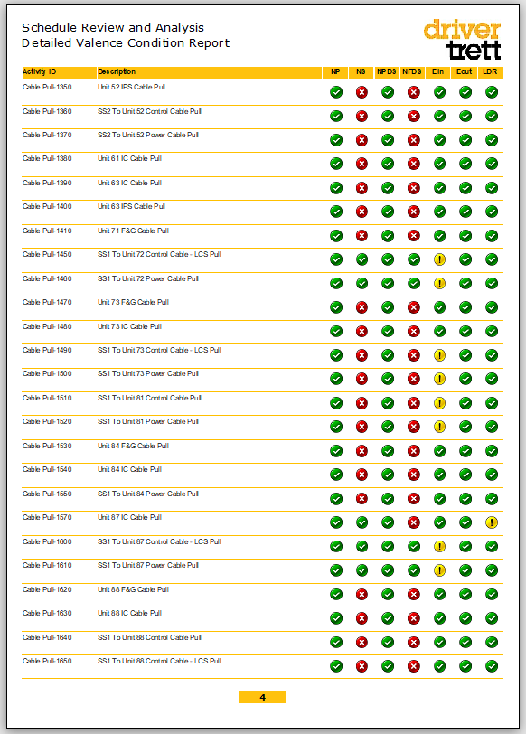

**If it meets the valence condition, there will be a yellow **

**Otherwise, a green tick **

**If it meets the valence condition, there will be a red **

**Otherwise, a green tick **

## SS-3 Detailed Logic

SS-3 gives us a detailed breakdown of each logic type per activity in the schedule.

**If it has a logic type of either SS or SF, there will be a yellow **

**Otherwise, a green tick **

**If it has a negative Lag or a high Lag, there will be a red **

**Otherwise, a green tick **

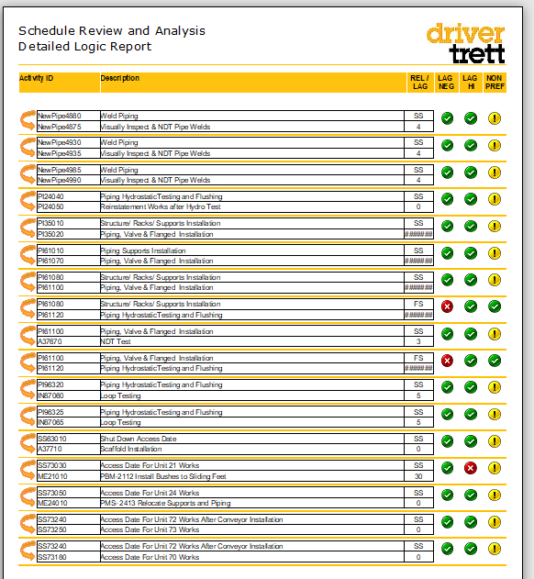

Each of the row follows the format drawn below:

**Predecessor Name**

**Successor Name**

**Logic Type**

**Predecessor ID**

**Lag Days**

**Successor ID**

## SS-4 Detailed Constraint

SS-4 gives us a detailed breakdown of each constraint type per activity in the schedule.

**If it has the constraint condition, there will be a red **

**Otherwise, a green tick **

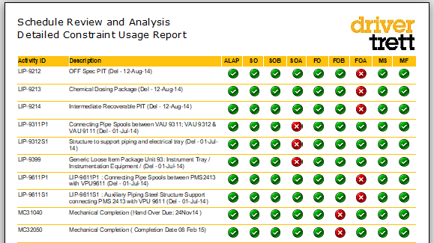

# Multi Schedule Reports

## MS-3 Activity Compare

MS-3 is a report that compares each activity across all the schedules selected with delay identification.

Before generating the report, we are given 4 options to filter the report:

1. By Activity Status
2. By Total Float Range
3. By Activity ID
4. By Activity Name

**Filter by Activity Status**

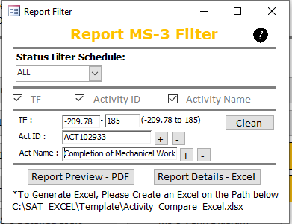

**Tick them to activate any one of these filters**

**By default, this displays the Minimum TF and Maximum TF of all the schedules selected**

**Select Clean to delete and restart**

**Select + to add in more filter layers**

To generate the report in PDF, click “**Report Preview – PDF**”.

To extract the report data in Excel, click “**Report Details – Excel**”.

The size of MS-3 report varies with the number of schedules selected for analysis, as well as the number of activities in these schedules. A huge report can go on to thousands of pages.

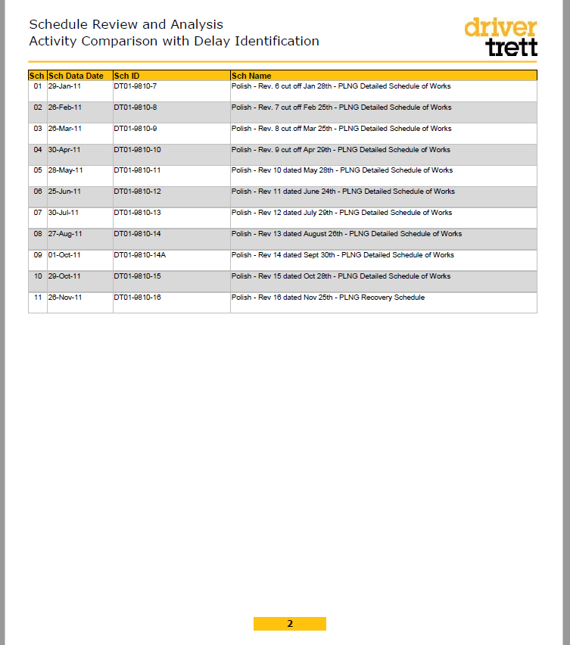On page 2, there is a summary table listing of all the schedules selected for analysis.

**Schedule Data Date**

**Schedule Index**

**Schedule ID**

**Schedule Name**

 IMPORTANT: Take note of the unique schedule index as the following pages would require these as references

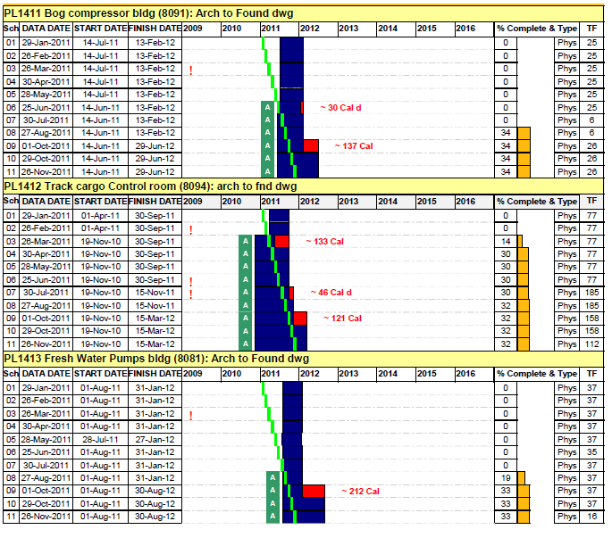Starting from page 3, each yellow-yellow band gives us information on 1 activity. The name and ID of the activity can be found on the yellow band.

**On activity “Bog compressor bldg”**

**On activity “Track cargo Control room”**

**On activity “Fresh Water Pumps bldg”**

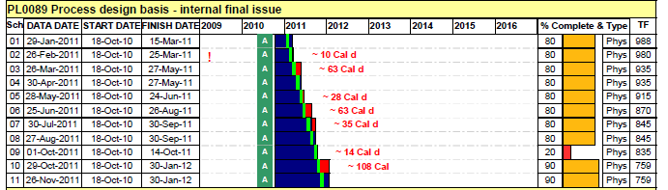On the left-hand side panel, if this activity exists in the schedules selected, a row with its schedule index will be generated.

 HOW TO READ: Activity “Process design basis” exists in schedule index 01, 02, 03, 04, 05, 06, 07, 08, 09, 10 and 11. The schedule index has a reference to the summary schedule listing on page 2.

For example, if the above activity exists in only schedule 02 and 03, there will only be two white rows generated.

Along with the schedule index, there are 3 other information displayed on the left-hand side panel - The schedule data date, the activity start date & the activity finish date.

A red exclamation mark **!** is displayed beside the schedule to notify a change in activity name in that schedule. The activity ID is kept constant.

 HOW TO READ:

In schedule index 02, activity “Process design basis” has a change in its name. The activity ID is still kept constant. This change is brought forward to all the subsequent schedule updates (i.e. schedule index 03, 04, 05, … all uses this new name).

If there appears 2 exclamation marks, this indicates that this activity has its name changed twice.

A green A at the start indicates an actualized start for the activity. A green A at the end indicates an actualized finish for the activity.

A blue bar spans from the activity start date to the activity finish date. The timeline is given at the top.

A lime green line is positioned at the schedule data date.

**Timeline**

**Data date**

**Actualised Start**

**Start-Finish duration**

**Actualised Finish**

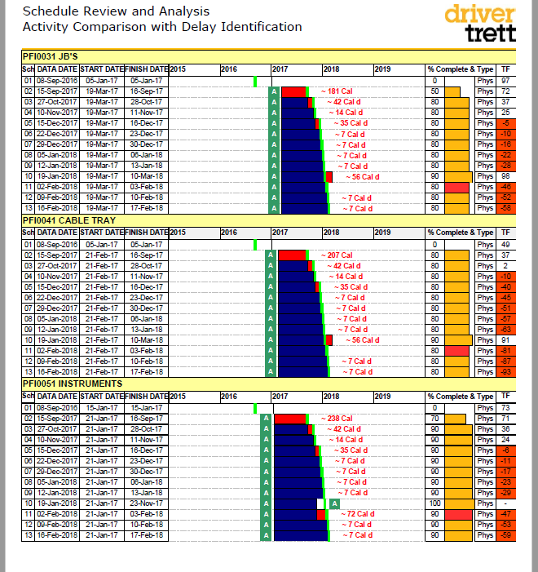

**!**

When an activity duration is increased, this potentially indicates a delay. In the graph, this is represented by a red bar. The number of days it is delayed is also shown in the red text.

**Delay**



**!**

 HOW TO READ:

In schedule index 11, there is a delay of 72 calendar days for activity “PFI0051 Instruments”.

The right-hand side of the report gives us the completion percentage, competition type, as well as the total float.

 IMPORTANT:

The completion bar turns red if there is a drop in completion % as compared to the previous, and the TF turns red if it’s negative.

**Completion % (and bars)**

**Completion Type**

**Total Float (in days)**



**!**

## MS-4 Activity / Logic Stats

MS-4 is a report that compares activity & logic statistics across all the schedules selected.

To generate the report in PDF, click “**Report Preview – PDF**”.

To extract the report data in Excel, click “**Report Details – Excel**”.

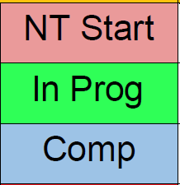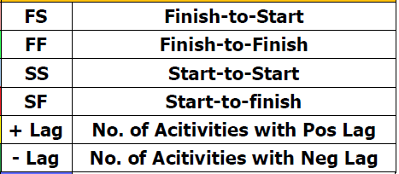Before we begin, all the legend needed for this report is shown on the very last page of MS-4.

**Valence condition abbreviation**

**Activity status – Not started / in progress / completed**

**Logic link & lag abbreviations**

**Critical float distribution**

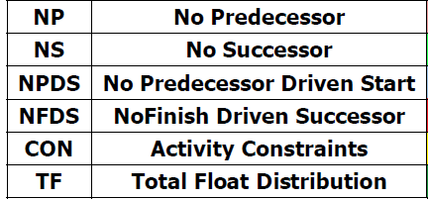

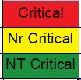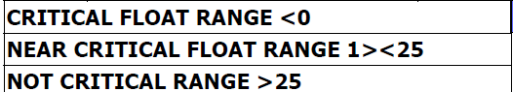

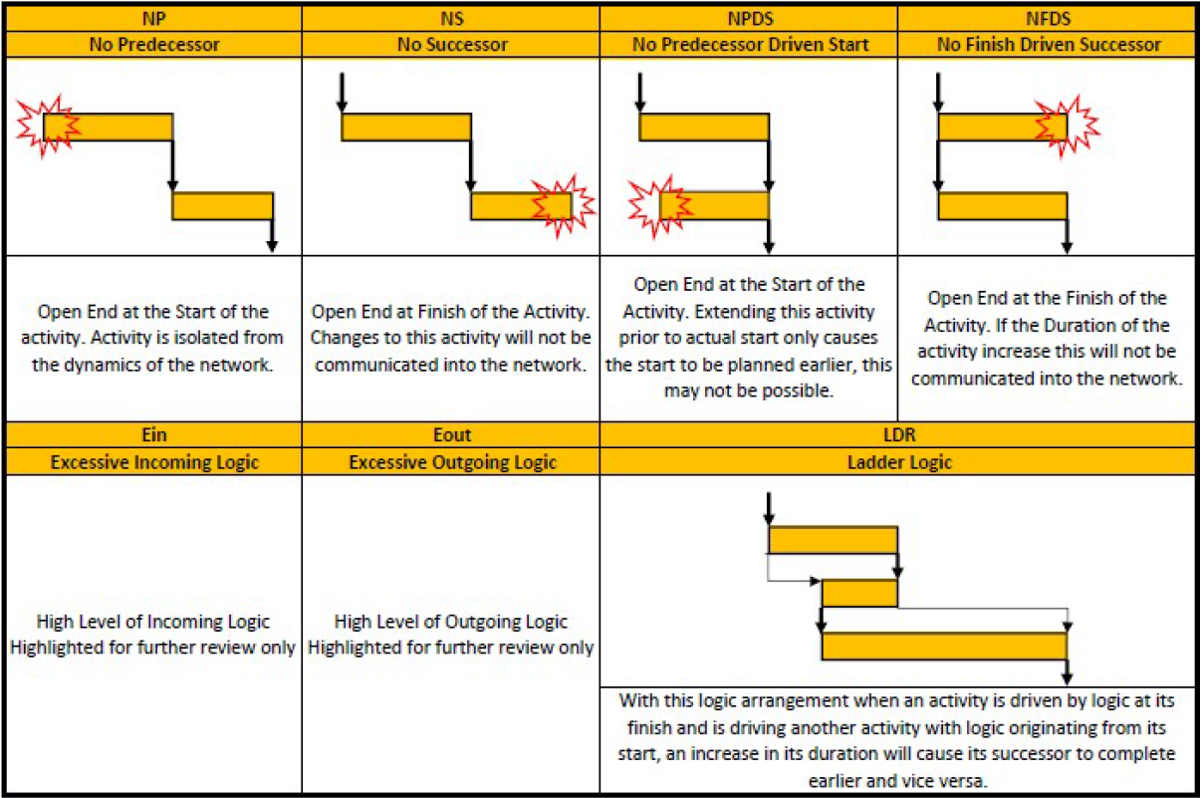

 IMPORTANT:

**EIN** = If there are more than 10 predecessors attached to an activity

**EOUT** = If there are more than 10 successors attached to an activity

**Valence condition explanation**

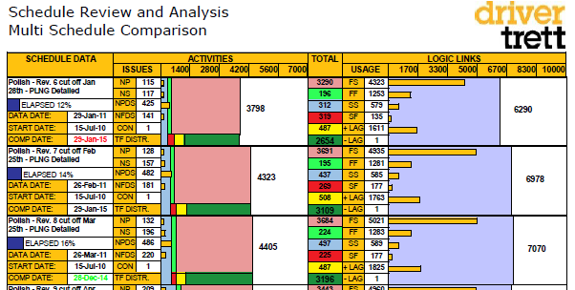Starting from page 2, each block gives us information on 1 schedule. The name of the schedule can be found in the top left-hand corner.

**About Rev 6**

**About Rev 7**

**About Rev 8**

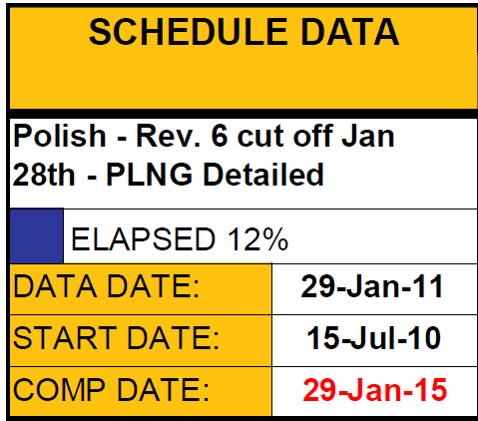In each block, the left-hand section gives us information about the schedule.

**Schedule Name**

**Schedule Data Date**

**Schedule Start Date**

**Schedule Completion Date**

 IMPORTANT:

The schedule completion date turns red if it’s later than the previous schedule’s completion date, turns green if it’s earlier, and remains black if it’s the same.

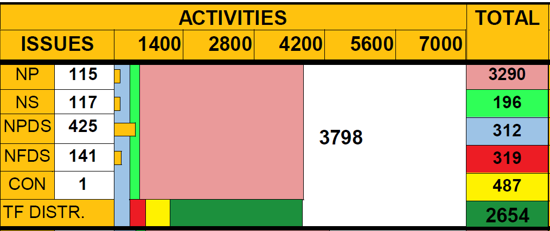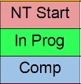The middle section gives us the count of the schedule’s valence condition.

 HOW TO READ: Out of activities that are ‘not started’ and ‘in progress’, there are 319 activities that are critical, 487 activities that are near critical, and 2654 activities that are not critical.

**Criticality breakdown**

 HOW TO READ: Out of 3798 activities, there are 3290 activities that are not started, 196 activities in progress, and 312 completed activities. The size of the boxes on the left corresponds to the number in it.

 HOW TO READ:   
There is 1 constraint in this schedule. (Refer to SS-1 to check for which constraint this is).

**Total number of activities**

**Activity status breakdown**

 HOW TO READ:   
There is 115 activities with NP, 117 activities with NS,  
425 activities with NPDS, 141 activities with NFDS.

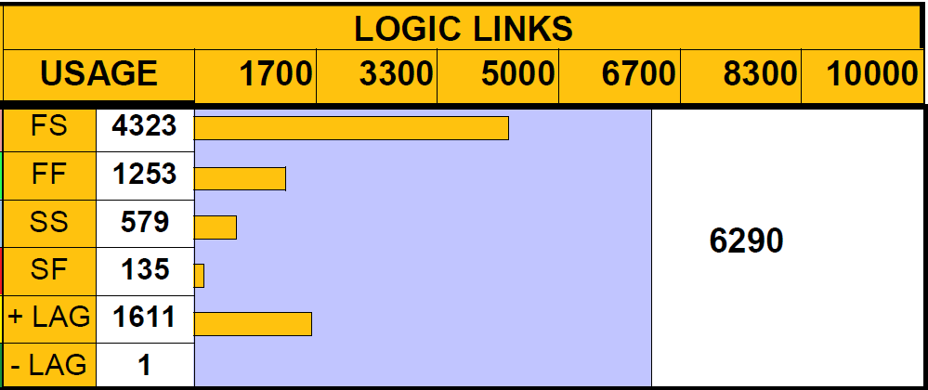The right section gives us the count of the schedule’s logic links.

 HOW TO READ:   
Out of 6290 logic links, 4323 are FS, 1253 are FF, 579 are SS and 135 are SF. In this schedule, there are 1611 logic links with a lag > 0, and 1 logic link with a lag < 0. The width of the horizontal bars corresponds to the number of links in it.

**Total number of logic links**

## MS-5 Venn Diagram

MS-5 is a report that compares 2 schedules at a time using Venn diagram.

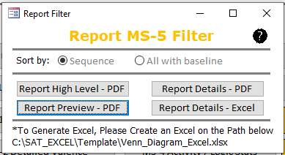Before generating the report, we are given 2 options to filter the report:

**A**

**B**

**C**

**E**

**D**

**E**

**B**

**D**

**C**

**Baseline**

 IMPORTANT:

1. **Sequence** (sorted by data date)

1. All with **baseline** (choose baseline)

**Filter by “sort by sequence” or “sort by all with baseline”**

There are 4 different types of reports to generate from:

1. **Report High Level – PDF**
   * Venn diagram report *without* predecessor / successor logic changes summary
2. **Report Preview – PDF**
   * Venn diagram report *with* predecessor / successor logic changes summary
3. **Report Details – PDF**
   * The report data generating this report in a PDF format
4. **Report Details – Excel**
   * The report data generating this report in an excel format

For each of the pairwise Venn diagram, the report is split into 2 schedules.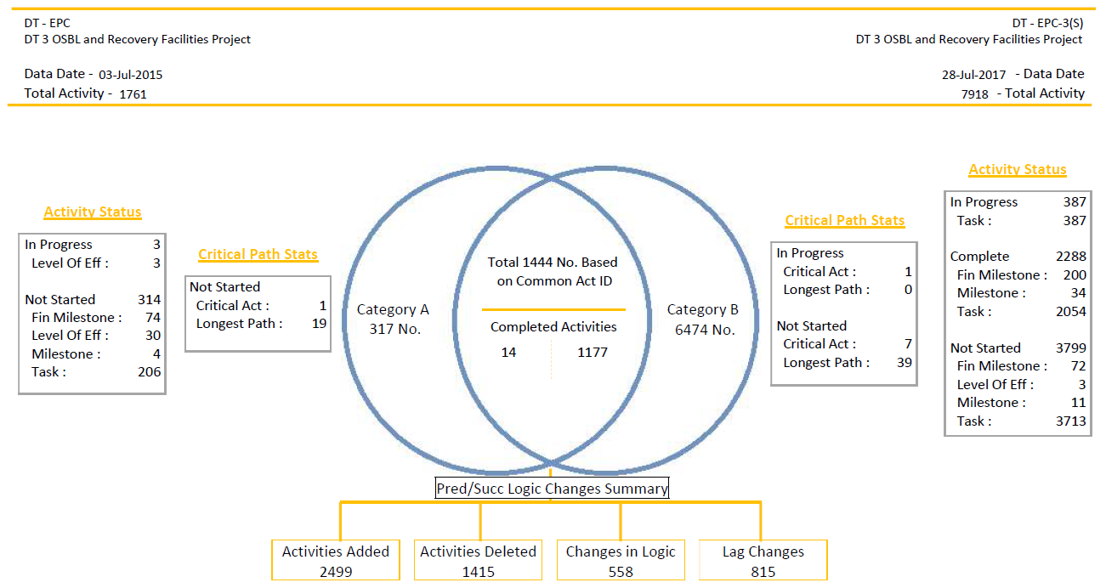

**All about schedule B**

**All about schedule A**

Information such as the schedule ID, schedule name, schedule data date, and the total number of activities are given in the top yellow band.

**Schedule B’s ID & Name**

**Schedule B’s data date**

**Schedule B’s activity count**

**Schedule A’s activity count**

**Schedule A’s data date**

**Schedule A’s ID & Name**

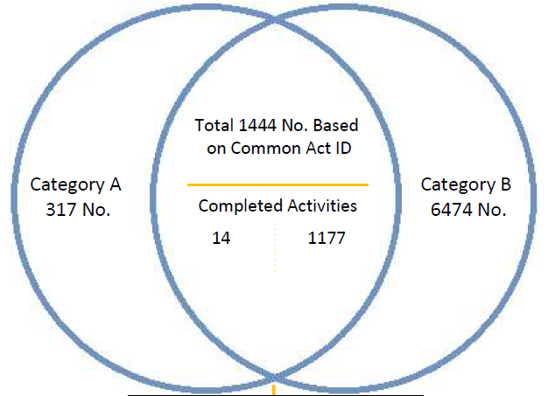The middle Venn diagram gives us the number of common activities based on its activity ID.

 IMPORTANT:   
1444 (common activities) + 317 (only in A) = 1761 (total activity count of A; seen above in yellow band)  
1444 (common activities) + 6474 (only in B) = 7918 (total activity count of B; seen above in yellow band)

1. All with **baseline** (choose baseline)

 HOW TO READ:   
There are 6474 activities in schedule B that are not in schedule A.

 HOW TO READ:   
There are 317 activities in schedule A that are not in schedule B.

 HOW TO READ:   
Out of these 1444 common activities, 14 of them are completed activities from schedule B

 HOW TO READ:   
Out of these 1444 common activities, 14 of them are completed activities from schedule A

 HOW TO READ:   
There are 1444 common activities in both schedule A and B

Outside of the Venn diagram, the boxes on either of the side is analysing the activities that are not common.

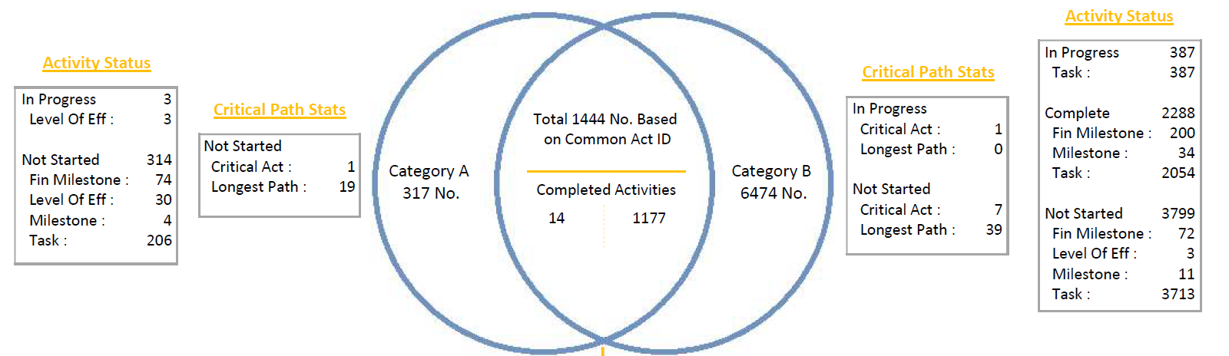

**Analyzing the 6474 activities that are only in schedule B**

**Analyzing the 317 activities that are only in schedule A**

The boxes on either side gives us a breakdown of the critical path stats and the activity status.

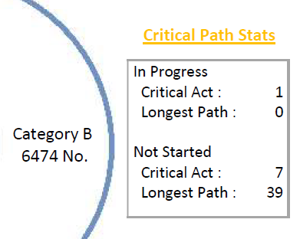

 HOW TO READ:   
Of the 6474 activities, there are 7 critical activities ‘not started’ in the critical path, and 39 activities ‘not started’ in the longest path.

 HOW TO READ:   
Of the 6474 activities, there are 1 critical activity ‘in progress’ in the critical path.

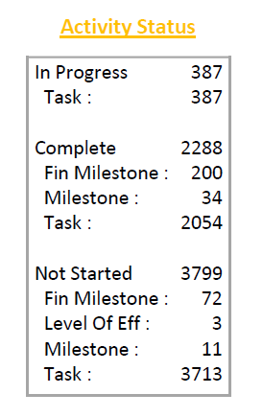

 HOW TO READ:   
Of the 3799 activities ‘not started’ =   
72 (finish milestones) + 3 (level of effort) + 11 (milestones) + 3713 (task)

 HOW TO READ:   
Of the 6474 activities = 387 (in progress) + 2288 (completed) + 3799 (not started)

The summary of predecessor and successor logic changes are given in bottom section.

 IMPORTANT:   
This is only generated if the option “Report Preview – PDF” is selected.

1. All with **baseline** (choose baseline)

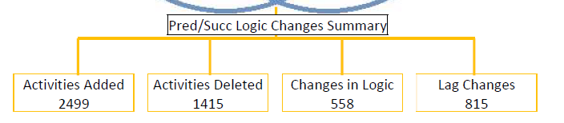

 HOW TO READ:   
When schedule A is updated to schedule B, **2499** activities were **added**

 HOW TO READ:   
When schedule A is updated to schedule B, **1415** activities were **deleted**

 HOW TO READ:   
When schedule A is updated to schedule B, **558** logic links were changed

 HOW TO READ:   
When schedule A is updated to schedule B, **815** logic links were changed

## MS-6 Activity Stats

MS-6 is a report that provides all the changes in valence condition happening to an activity across multiple schedules.

Before generating the report, we are first required to perform some configurations:

**Tick them to activate any one of these filters**

**Select + to add in more filter layers**

**Sort multiple schedules by “sequence” or with “baseline”**

**A**

**E**

**B**

**D**

**C**

**Baseline**

**E**

**B**

**D**

**C**

 IMPORTANT:

* **Sequence** (sorted by data date)

* All with **baseline** (choose baseline)

**Sort multiple schedules by “sequence” or with “baseline”**

**Filtering report data**

**Showing *all* the valence information in *all activities* per schedule comparison**

**Showing *all* the valence information in the *common activities* per schedule comparison**

**Showing only valence *changes* in the *common activities* per schedule comparison**

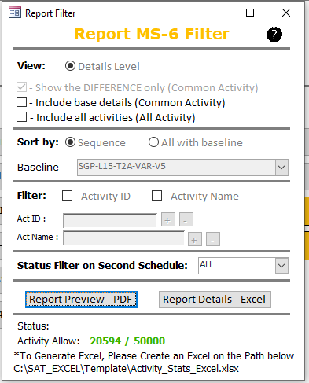

To generate the report in PDF, click “**Report Preview – PDF**”.

To extract the report data in Excel, click “**Report Details – Excel**”.

Before we begin, there are 6 colour schemes:

1. **Green - Added**
2. **Red - Deleted**
3. **Yellow – Lag changes**
4. **Blue – Relationship changes**
5. **Purple - Both Lag & Relationship changes**
6. **White – No Changes**

 IMPORTANT: For white – no changes, there are no changes to this activity.

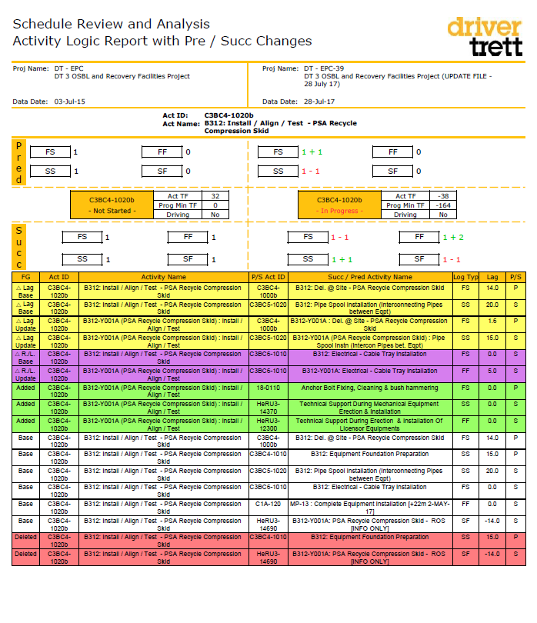In every page of the pairwise schedule comparison, the schedule details are given at the top, and the table has a standardised yellow band.

**Schedule B Details**

**Schedule A Details**

* **FG = Flag**
* **Activity ID**
* **Activity Name**
* **P/S Act ID = Predecessor / Successor activity ID**
* **Logic**
* **Lag duration**
* **P/S = Predecessor / Successor**

**1**

**Activity ID & Name**

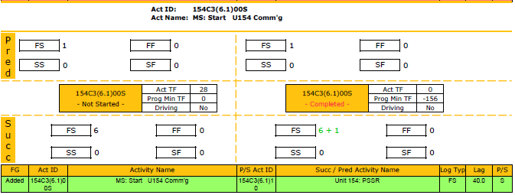

**A valence of “FS” was added to it in the successor**

**The added valence details**

 HOW TO READ:   
In the previous schedule, there were 6 Finish-to-Start successor relationships. In the next schedule update, 1 Finish-to-Start successor relationship was added, totalling up to 7. The added relationship is connected to the Activity mentioned in the green highlighted row.

**Activity ID & Name**

**2**

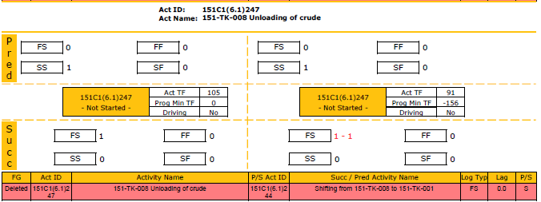

**The deleted valence details**

**A valence of “FS” was deleted in the successor**

 HOW TO READ:   
In the previous schedule, there were 1 Finish-to-Start successor relationship. In the next schedule update, that Finish-to-Start successor relationship was deleted, totalling up to 0. The deleted relationship is connected to the Activity mentioned in the red highlighted row.

**3**

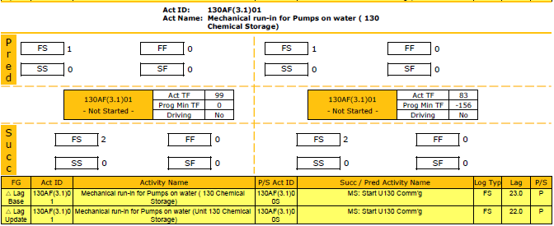

**Change in lag**

**The change in lag details**

**Activity ID & Name**

 HOW TO READ:   
In the previous schedule, the lag duration for its Finish-to-Start predecessor relationship was 23 days. In the next schedule update, the lag got decreased to 22 days.

**Activity ID & Name**

**4**

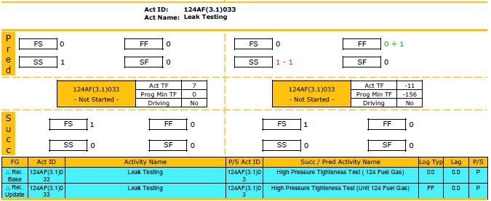

**FF + 1**

**SS - 1**

**The change in valence details**

**Change from SS to FF**

 HOW TO READ:   
In the previous schedule, there was a Start-to-Start predecessor relationship. In the next schedule update, it got changed to a Finish-to-Finish predecessor relationship. The details are shown in the cyan highlighted row.

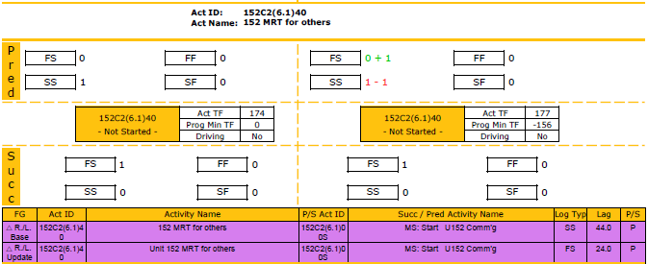

 HOW TO READ:   
In the previous schedule, there was a Start-to-Start predecessor relationship with a lag of 44 days. In the next schedule update, it got changed to a Finish-to-Start predecessor relationship with a lag of 24 days. Both changes are mentioned in the purple highlighted row.

**Change from SS to FS**

**Change from SS to FS & change in lag**

**The change in both valence & lag details**

**5**

**Activity ID & Name**

## MS-7 Float Map

MS-7 is a float map report.

Before generating the report, we can filter the report 2 ways - Its activity status, or its activity ID/name.

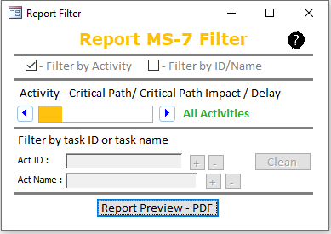

**Activity Status**

**Select + to add in more filter layers**

**Select Clean to delete and restart**

**Tick them to activate any one of these filters**

For the activity status, there are a few options as we click through the arrow:

* All activities
* Float < 0 = Activities with float < 0
* Critical Path = Activities on the Critical Path
* Critical Path Impact = Activities that has a Critical Path Impact
* Delay = Activities with Delay

The definitions are as follow:

 IMPORTANT:

**Delay**

1. Total Float = Minimum Total Float
2. Activities with **NO** actualised finish
3. Current Total Float < Previous schedule’s Total Float
4. Current Duration > Previous schedule’s Duration

 IMPORTANT:

**Critical Path Impact**

1. Total Float = Minimum Total Float
2. Activities with **NO** actualised finish
3. Current Total Float < Previous schedule’s Total Float

 IMPORTANT:

**Critical Path**

1. Total Float = Minimum Total Float
2. Activities with **NO** actualised finish

To generate the report in PDF, click “**Report Preview – PDF**”.

In each page of the report, the schedules’ data dates are sorted ascendingly at the top. The number of columns depends on the number of schedules we have selected to generate this report.

**Schedule 4 Data Date**

**Schedule 3 Data Date**

**Schedule 2 Data Date**

**Schedule 1 Data Date**

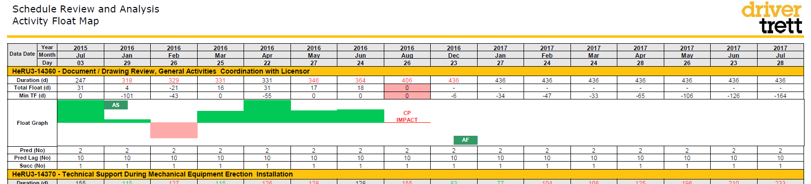

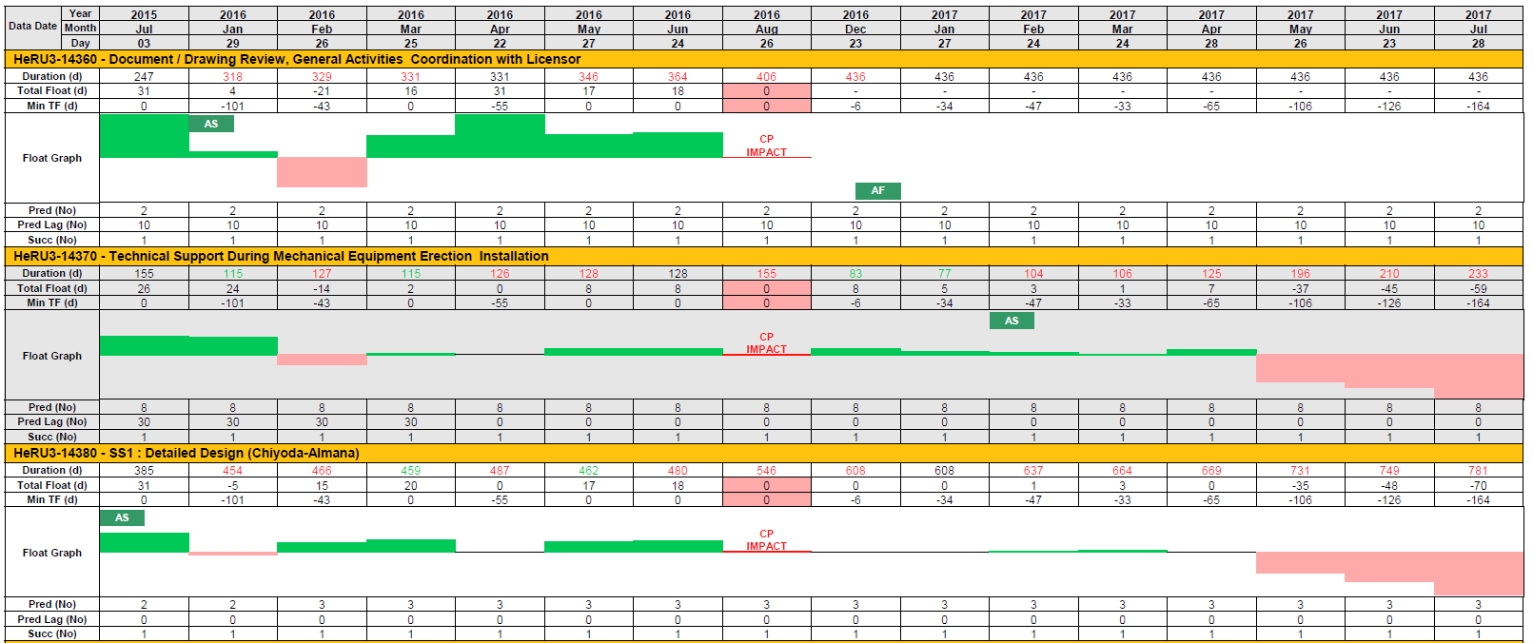Each yellow-to-yellow band gives us information on 1 activity. The name and ID of the activity can be found on the yellow band.

**About Activity 14380**

**About Activity 14370**

**About Activity 14360**

In each band, the top 3 rows show the **duration** of the activity in that schedule / the **total float** of the activity in that schedule / **minimum total floa**t of the schedule *in days.*

**Turns green if duration had decreased, and red if increased, when compared to the previous schedule**



IMPORTANT: Shaded red when activity’s Total Float = Minimum Total Float of the schedule

The middle section shows the float graph of that activity across all schedules visually. The height of the bars corresponds to the number of days in the float (given above).

**Positive float goes upwards in green**

**Float = 0**

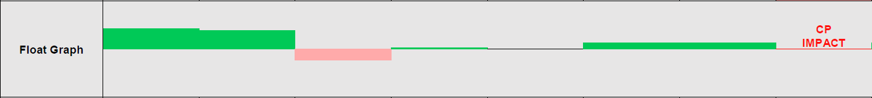



**Missing data**

**Negative float goes downwards in red**

If there is an , that activity has an **Actualised Start** in that schedule.

If there is an , that activity has an **Actualised Finish** in that schedule.

If there is an 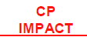, that activity has a **Critical Path Impact** and it meets the 4 criteria defined in the definition earlier.

The bottom 3 rows gives the *number* of **predecessor** of the activity/ the **sum of** **predecessor lags** of the activity / the number of **successor** of that activity.

## MS-8 Schedule Consistency

MS-8 is a 3-page report, with each page containing a graph:

1. Baseline continuity graph
2. Milestone graph
3. Schedule consistency graph

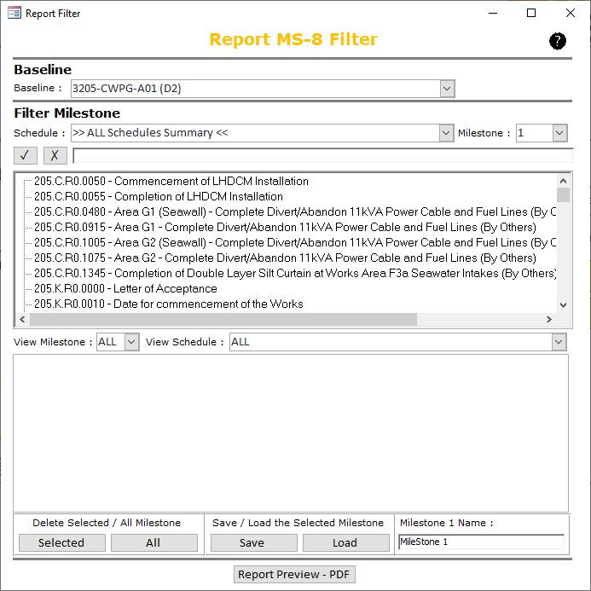Before generating the report, we will have to work through the configuration page. Let’s get started.

**Milestone Table**

**Milestone List**

**Baseline**

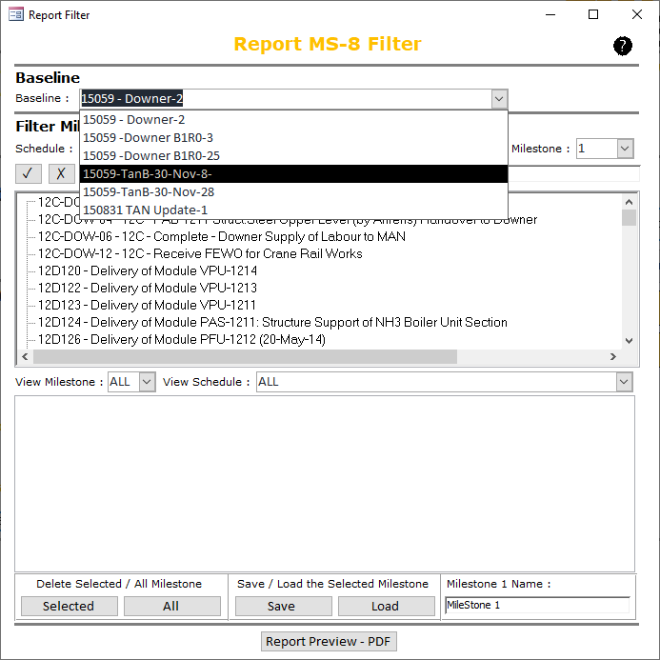The first step would be to set the baseline. By default, the schedules are sorted ascendingly by data date, and the schedule with the earliest data date is chosen to be the baseline. Alternatively, we can change this via the list of dropdowns.

**Choose Baseline**

**Choose baseline**

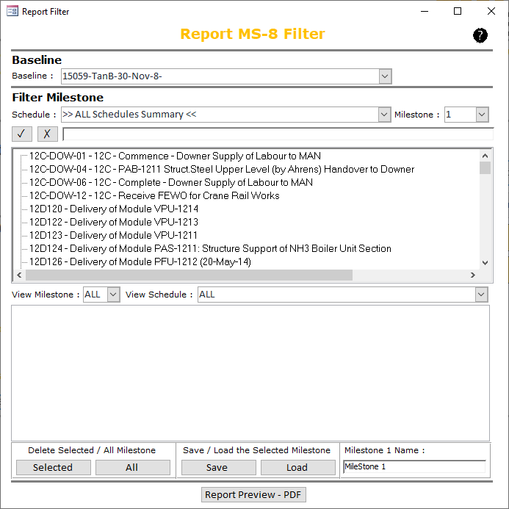After the baseline is chosen, we can move on to populating our milestones. The list of all milestones is given in the window below:

**List of milestones**

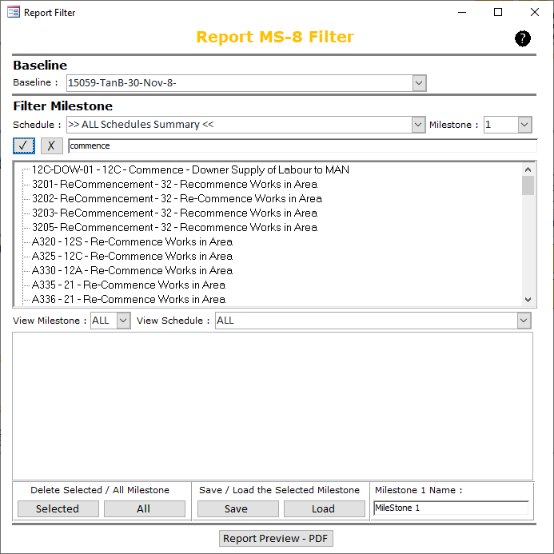We can also easily search for a specific milestone in the search bar. Start typing and click  when we are done.

**Search bar +**

**Filtered milestones with matching keywords**

We can easily clear the keywords in the search bar by clicking .

IMPORTANT: We can only select up to **a MAXIMUM OF 4** milestones.

To select a milestone, double-click on it. 3 things happened after we have selected:

1. Milestone number increased by 1
2. Milestone gets populated into the milestone table below
3. 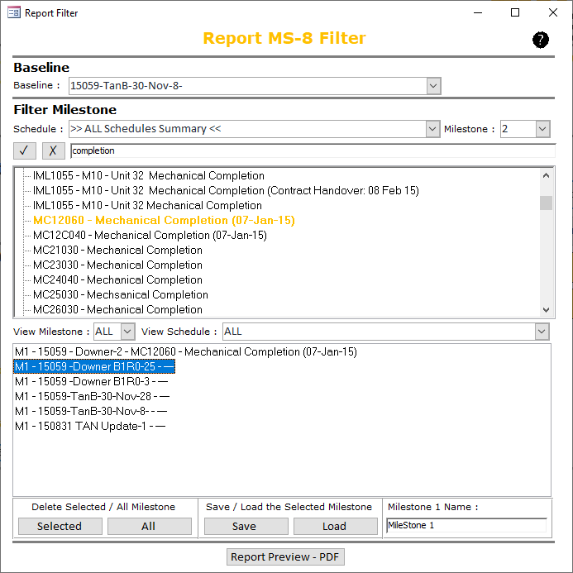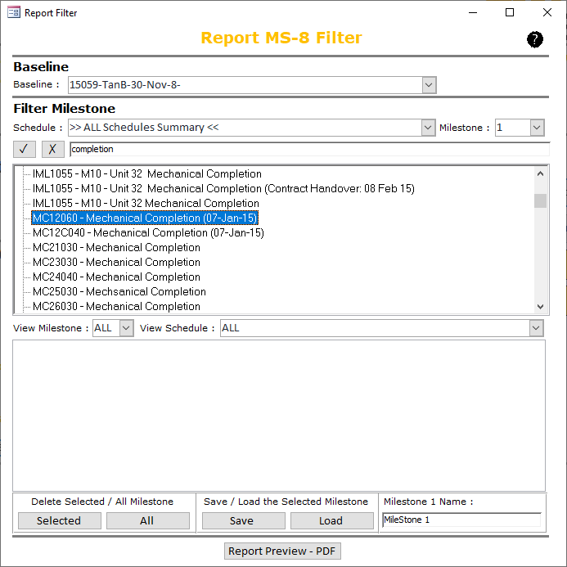Milestones that have been selected will be highlighted in orange in the milestone list

**1**

**2**

**3**

IMPORTANT: **MAXIMUM = 4**

**Milestone number + 1**

**Selected milestone highlighted in orange**

**Milestone populated**

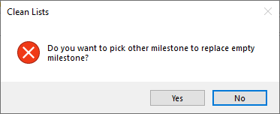If at least 1 out of the many schedules selected does not have the milestones, a message will pup. If this happens, we can first click on “**NO**”. We will come back to this later.

The missing milestones can be further verified in the milestone table below.

**EMPTY**

 HOW TO READ:   
Of all the schedules selected, only “***Downer-2***” has the milestone “***MC12060-Mehanical Completion (07-Jan-15)***”. The rest of the schedules do not have this milestone. This could be caused by either of the 2 reasons:

1. ID has been changed
2. The milestone simply does not exist

If we know the milestone does exists but the ID has been changed, we can “replace” it.

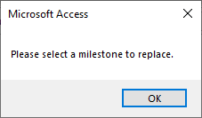To “replace” it, click into any of the empty ones in the milestone table. The following message will appear, then click “OK”.

The milestone list will be refreshed with a list of milestones in that schedule. We can either scroll and look through it, or type in the keyword into the search bar. Finally, click into it. Repeat this procedure to replace the missing milestones.

When all our milestones have been selected, we can further check them in the milestone table by selecting the dropdowns:

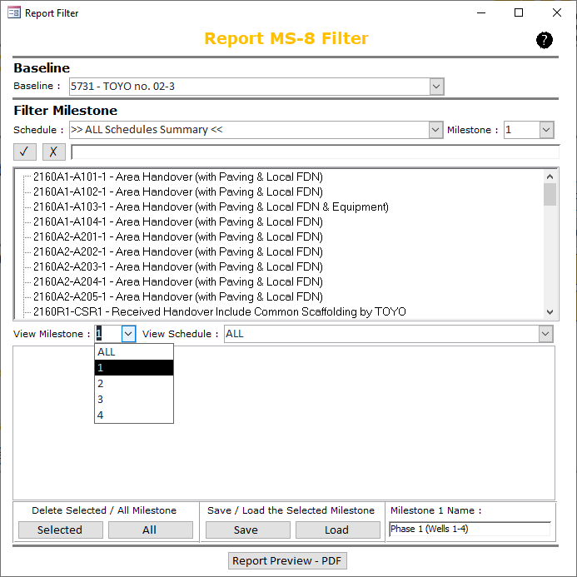

We can also name the milestones such that it will be correctly represented in the report that is about to populate.



After the setup is completed, we can **SAVE** it so that the next time we open SAT, we can easily **LOAD** it back to retrieve our previously saved setup.

Or, we can **DELETE** selected milestone or **DELETE ALL** milestone to clean up the milestones.



Finally, click on “Report Preview – PDF” to generate the report.

MS-8 is a 3-page report, with each page containing a graph:

1. Baseline continuity graph
2. Milestone graph
3. Schedule consistency graph

**The Baseline Continuity graph**

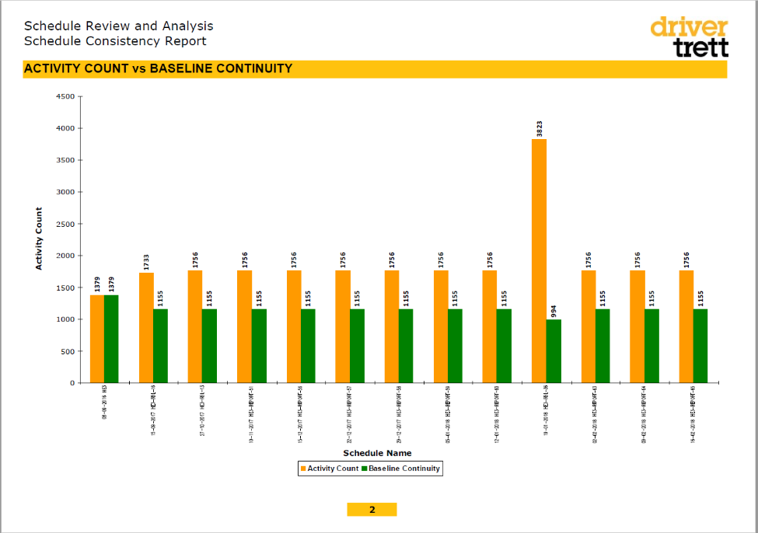This graph shows the continuity of baseline activities across schedules.

* The number of columns is dependent on the number of schedules selected
* Schedules are sorted by data date, with the baseline schedule in the first column
* Orange bar = total activity count
* Green bar = count of baseline activities

 HOW TO READ:

* 13 schedules were selected for review.
* The activity count has been consistent up till schedule 10 where it increased by 3 folds, and then dropped back to the 1756 in schedule 11.
* The baseline continuity is consistent too, besides the slight dip in schedule 10.

IMPORTANT:   
Baseline schedule is in the first column. Total activity count = count of baseline activities. It should always be equal.

**The Milestone graph**

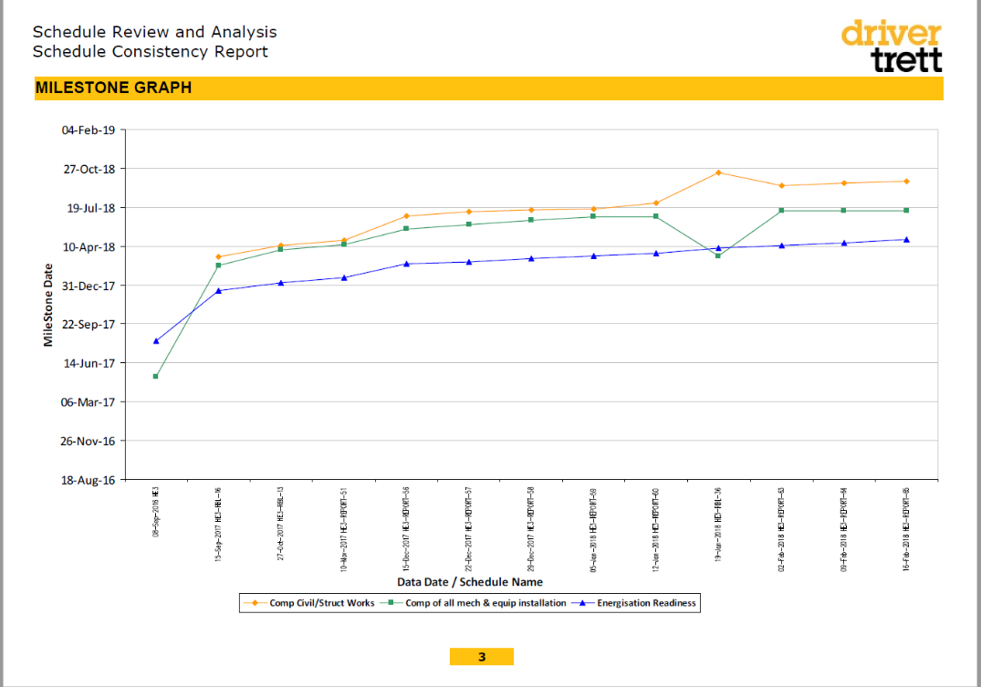This graph shows the trend of milestones (up to 4) across schedules.

* The number of columns is dependent on the number of schedules selected
* Schedules are sorted by data date, with the baseline schedule in the first column
* Each milestone line can be referenced with the legend introduced at the bottom
* The date of the milestone can be reference with the date axis on the left

 HOW TO READ:

* 13 schedules were selected for review.
* Milestone “Energisation Readiness” has slipped from approximately July 2017 to April 2018 since the baseline.
* Milestone “Comp Civil/Struct Works” shows quite a significant slippage on the 10th schedule
* Milestone “Comp of all mech & equip installation” was brought forward by approximately 4 months in the 10th schedule.

**The Schedule Consistency graph**

This graph shows the availability of schedules across the timespan of the project.

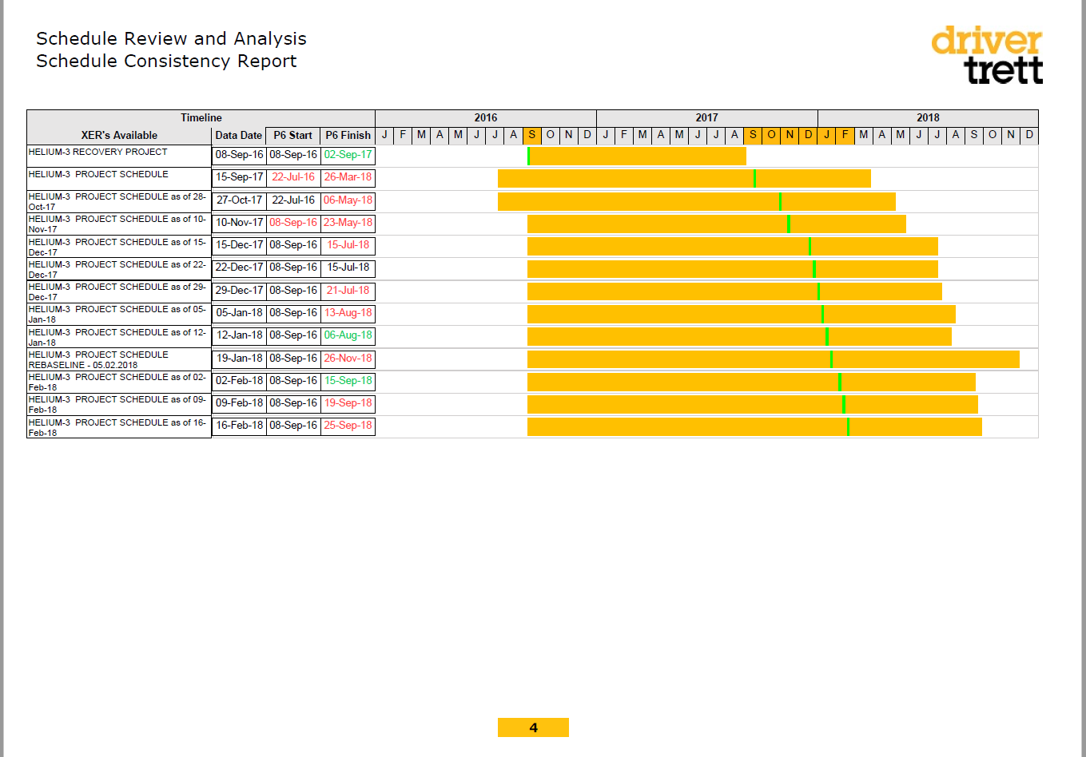

* The number of rows is dependent on the number of schedules selected
* The data date, start date, finish date of the schedule is given as the 3 data fields in the table
* For the start / finish date, it turns red if the date is later than the previous, and green if it’s earlier than the previous
* The horizontal orange bar represents the start to end date of the schedule
* The lime green line represents the data date
* The data date corresponds to the highlighted months shown on the timeline axis at the top

 HOW TO READ:

* 13 schedules were selected for review.
* We have the baseline schedules on September 2016, and the subsequent 12 updates were from September 2017 – February 2018.
* There is a gap of 1 year (October 2016 – August 2017) that we do not have schedule updates for.

# Automatic Word Export

## Defense Contract Management Agency (DCMA)

The DCMA schedule assessment is a widely used guideline to inspect the quality of project schedules.

It contains a set of 14 quantitative assessment based on measurable criteria rooted in industry-defined schedule best practices.

The 14 quantitative assessments are:

**Logic**The logic check looks to ensure all incomplete activities have defined predecessors and successors.

**Leads**  
This check looks to identifies any incomplete activities that are carrying a lead (also known as a negative lag).

**Lags**  
An evaluation of the % of project activities that have a positive lag between each other. Excessive use of lags can cause an obstruction to the critical path analysis.

**Relationship Types**  
It is recommended that the 90% of the project activities are of a finish-to-start type (FS).

**Hard Constraints**  
It is recommended that no more than 5% of the incomplete activities should use hard constraints because they can provoke problems in the schedule.

**High-Float**  
High float is more often the result of missing dependencies. It is recommended that no more than 5% of the incomplete activities has a total float greater than 44 working days.

**Negative Float**  
Negative float occurs when the project schedule is forecasting a missed deadline, or when a hard constraint is holding a task further to the left than it would otherwise be.

**High Duration**  
Activities with high duration should be broken down so they can be measurable and controllable. It is recommended that no more than 5% of incomplete activities should last longer than 44 working days.

**Invalid Dates**  
An activity is considered to have invalid dates if it has forecast start/finish dates in the past or actual start/finish dates in the future.

**Resources**  
It is recommended that all activities should have resources assigned to them.

**Missed Tasks**  
It measures the schedule performance in parallel to the baseline plan. Particularly, the number of missing tasks can indicate how well or badly the project schedule meets the baseline schedule.

**Critical Path Test**  
The critical path test is a Boolean pass/fail metric intended to evaluate the integrity of the network logic in the schedule. This test is performed by first identifying the critical path in the schedule, and then intentionally introducing some amount of schedule slip to the first task on the path. If a commensurate amount of schedule slip occurs on the project finish milestone, the test has been passed. A failed test is indicative of missed dependencies and requires deeper analysis of the network logic.

**Critical Path Length Index**  
The Critical Path Length Index (CPLI) presents the measure of the efficiency necessary for completing a milestone on assigned time. CPLI evaluates the integrity of the overall network logic and measures the ‘realism’ of completing a project successfully.

**Baseline Execution Index**  
The Baseline Execution Index (BEI) test is a metric for evaluating schedule performance in parallel with the baseline plan but it focuses on the project’s team productivity in the process of executing activities.

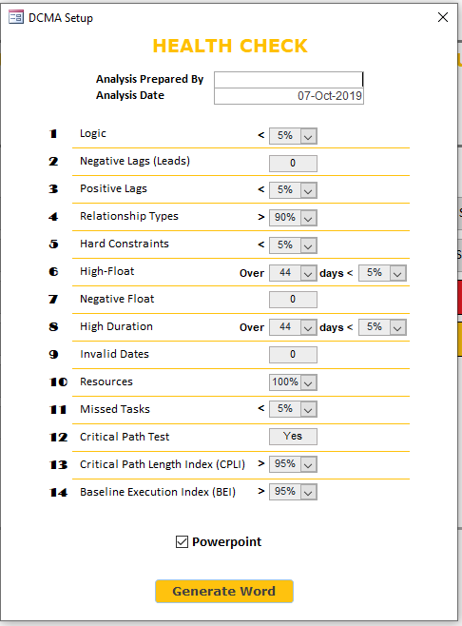To generate the report, first enter our name into the text field. The rest of the metrics has a default value, we can easily change them by clicking on the dropdown. When everything is adjusted, click on “Generate Word”.

**Adjust Appropriately Date**

**Enter Date**

**Enter Name**

IMPORTANT:   
The report is fully generated when the ***Table of Figures*** appear on the 2nd page.

IMPORTANT:   
Remember to save the file into our specified directory and give it a title.

The report is in Microsoft Word format.

The 2nd page contains the Table of Figures.

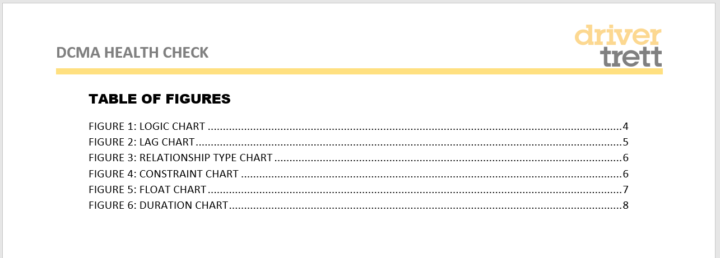

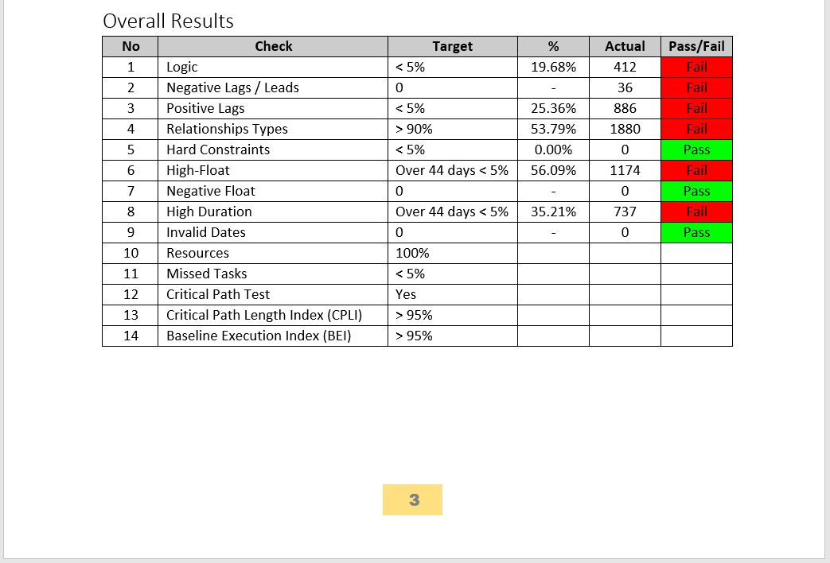The 3rd page contains the summary Pass/Fail metric of the 14 assessments.

**Summary glance of 14 assessment metrics**

**Schedule Data**

**Schedule Details**

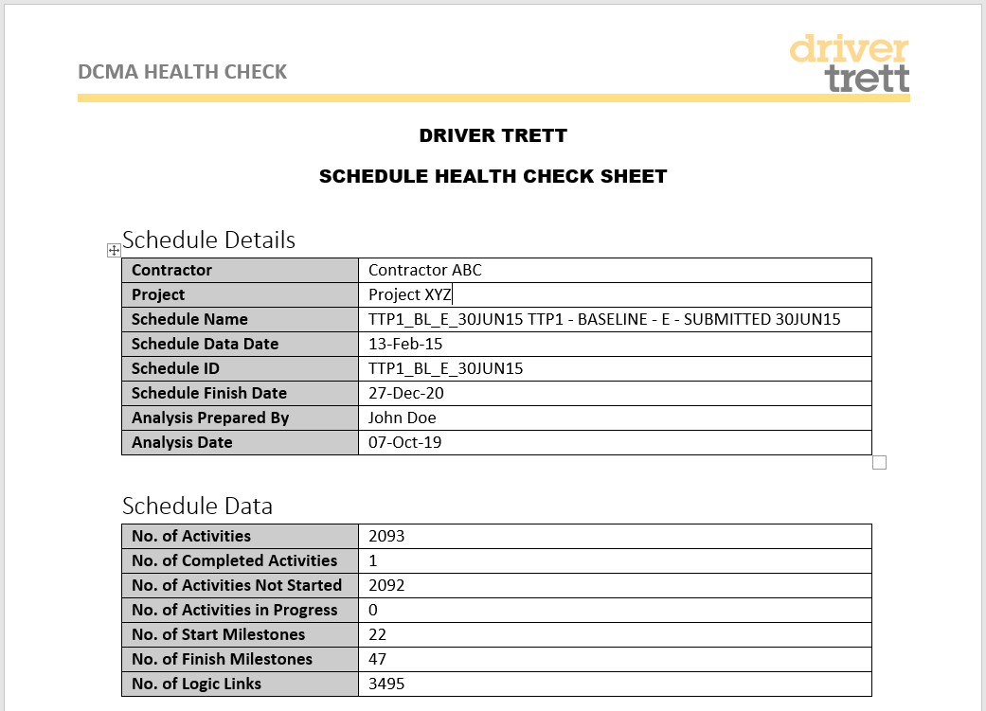

From page 4 onwards, each paragraph explains the metric that is being assessed, as well as giving us a chart/graph.

IMPORTANT:   
Paragraphs marked with “XXX” are for individual consultants to populate themselves.

## Phase 1 Report

This report acts as an early deliverable. It provides a quick understanding of schedule quality and the area of delays by analysing metrics like valence conditions, relationships, lags, constraints and floats.

Click on “Generate Word” to generate the report.

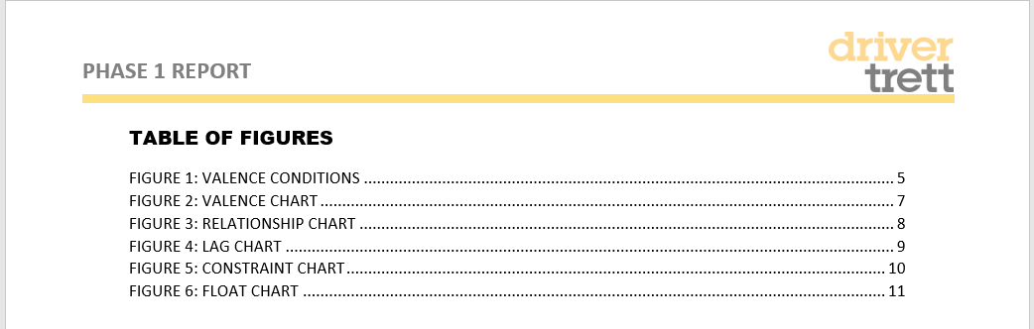

IMPORTANT:   
The report is fully generated when the ***Table of Figures*** appear on the 2nd page.

IMPORTANT:   
Remember to save the file into our specified directory and give it a title.

From page 3 onwards, each paragraph explains the metric that is being assessed, as well as giving us a chart/graph.

IMPORTANT:   
Paragraphs marked with “XXX” are for individual consultants to populate themselves.

# Contact Us

GDDT@DRIVERTRETT.COM